7.2.8 Editors - 3D View - Header - Sculpt mode menus
Detailed Table of content 1
Sculpt Mode - Sculpt Menu 2
Subdivide 2
Last Operator Subdivision Set 2
Sculpt Mode - Brush Menu 2
Reset Brush 2
Sculpt Mode - Hide/Mask Menu 2
Lasso Mask 3
Box Mask 3
Clear Mask 3
Fill Mask 3
Invert Mask 3
Hide Masked 3
Show Bounding Box 3
Hide Bounding Box 4
Show All 4

Detailed Table of content

Sculpt Mode - Sculpt Menu

The Sculpt menu contains just one menu item at the moment. Subdivide.

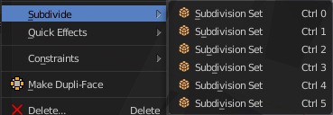
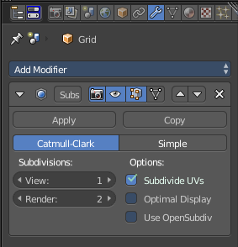
Subdivide
Subdivide is a menu where you can quickly set the subdivision level of the selection.
What it does is to add a SDS modifier in the Properties Editor if required. And set the SDS level to the needed value.
Crtrl 0 sets SDS to level 0. Ctrl 1 sets SDS level to 1 , and so on.
SDS happens at Object mode level. Even when you apply it in the Sculpt Mode! And it happens at the whole object.

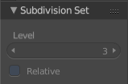
Last Operator Subdivision Set
The last operator Subdivision Set is greyed out in Sculpt mode.

Sculpt Mode - Brush Menu

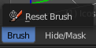
This menu contains brush related tools.

Reset Brush
Resets the current brush size to default size.

Sculpt Mode - Hide/Mask Menu
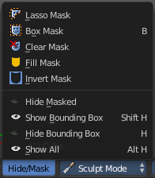
This menu contains some masking functionality.

Masking is a way to control which areas of the mesh are influenced by sculpting. To edit a mask manually, select the Mask Brush from the Brush panel.

Masked parts turns black.
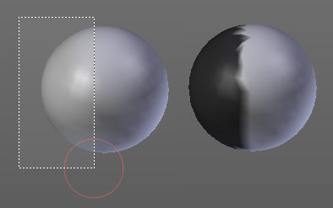
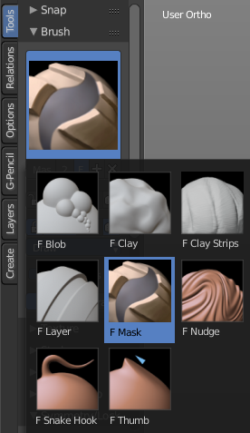

Lasso Mask
Select part of the mesh with a lasso tool.
Hotkey only tool, since the menu item is a bad starting point.

Box Mask
Select part of the mesh with a Rectangle tool.

Clear Mask
Clears the mask.

Fill Mask
Fills the mask with a given value, or inverts its values.

Invert Mask
Inverts the mask.

Hide Masked
Hides the masked mesh part.

Show Bounding Box
Lets you rectangle select a screen area to make hidden masked parts visible again.

Hide Bounding Box
Lets you rectangle select a screen area to hide mesh parts.

Show All
Makes all invisible mesh parts visible again.

